Batch - Deferred Settlement
# Source: AI Source: Provided by: [Data Path: Persons Table -> ID Column: 1, Name_En Column: Motasem Essam] -> From: [ChatGPT] on [1/21/2026]
Batch or Deferred Settlement in mobile money refers to when transactions are recorded instantly, but the actual transfer of funds between financial institutions or parties happens later — usually in scheduled batches (e.g., at the end of the day). This model is often used for wallet-to-bank, inter-operator, or merchant settlements.

🧠 Simple Definition
# Source: AI Source: Provided by: [Data Path: Persons Table -> ID Column: 1, Name_En Column: Motasem Essam] -> From: [ChatGPT] on [1/21/2026]
In batch/deferred settlement, the payment is processed now, but the money moves between systems later, often once a day or in defined time windows.

🛠️ How It Works
# Source: AI Source: Provided by: [Data Path: Persons Table -> ID Column: 1, Name_En Column: Motasem Essam] -> From: [ChatGPT] on [1/21/2026]
- A user pays a merchant using mobile money (e.g., Vodafone Cash).
- The transaction is marked as successful and recorded in the system.
- The merchant’s wallet shows a credit immediately.
- Behind the scenes, actual money is settled later in a batch — e.g., funds are transferred from Vodafone’s pooled bank account to the merchant’s bank account in bulk.
- This is handled through a settlement engine or via ACH/RTGS networks.

✅ Common Use Cases
# Source: AI Source: Provided by: [Data Path: Persons Table -> ID Column: 1, Name_En Column: Motasem Essam] -> From: [ChatGPT] on [1/21/2026]
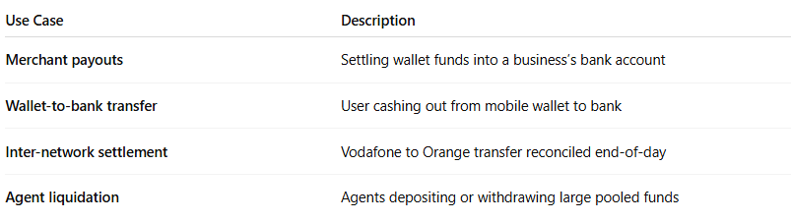

Use Case | Description
Merchant payouts | Settling wallet funds into a business’s bank account
Wallet-to-bank transfer | User cashing out from mobile wallet to bank
Inter-network settlement | Vodafone to Orange transfer reconciled end-of-day
Agent liquidation | Agents depositing or withdrawing large pooled funds

🔁 Examples by Region
# Source: AI Source: Provided by: [Data Path: Persons Table -> ID Column: 1, Name_En Column: Motasem Essam] -> From: [ChatGPT] on [1/21/2026]
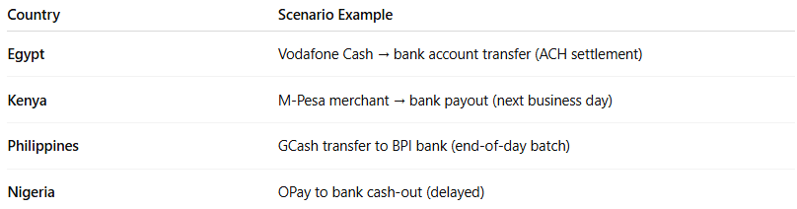

Country | Scenario Example
Egypt | Vodafone Cash → bank account transfer (ACH settlement)
Kenya | M-Pesa merchant → bank payout (next business day)
Philippines | GCash transfer to BPI bank (end-of-day batch)
Nigeria | OPay to bank cash-out (delayed)

🧾 Settlement Characteristics
# Source: AI Source: Provided by: [Data Path: Persons Table -> ID Column: 1, Name_En Column: Motasem Essam] -> From: [ChatGPT] on [1/21/2026]
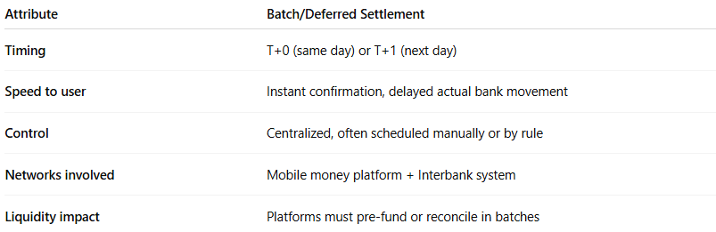

Attribute | Batch/Deferred Settlement
Timing | T+0 (same day) or T+1 (next day)
Speed to user | Instant confirmation, delayed actual bank movement
Control | Centralized, often scheduled manually or by rule
Networks involved | Mobile money platform + Interbank system
Liquidity impact | Platforms must pre-fund or reconcile in batches

🔐 Why Use Batch/Deferred Settlement?
# Source: AI Source: Provided by: [Data Path: Persons Table -> ID Column: 1, Name_En Column: Motasem Essam] -> From: [ChatGPT] on [1/21/2026]
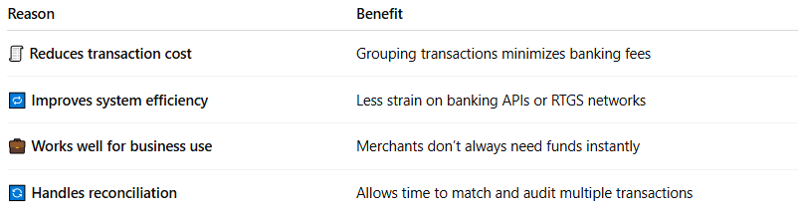

Reason | Benefit
🧾 Reduces transaction cost | Grouping transactions minimizes banking fees
🔁 Improves system efficiency | Less strain on banking APIs or RTGS networks
💼 Works well for business use | Merchants don’t always need funds instantly
🔄 Handles reconciliation | Allows time to match and audit multiple transactions

⚠️ Limitations / Considerations
# Source: AI Source: Provided by: [Data Path: Persons Table -> ID Column: 1, Name_En Column: Motasem Essam] -> From: [ChatGPT] on [1/21/2026]
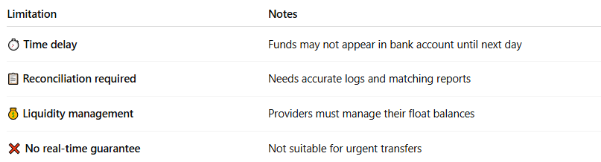

Limitation | Notes
⏱️ Time delay | Funds may not appear in bank account until next day
📋 Reconciliation required | Needs accurate logs and matching reports
💰 Liquidity management | Providers must manage their float balances
❌ No real-time guarantee | Not suitable for urgent transfers

📊 Real-Time vs Batch/Deferred Settlement in Mobile Money
# Source: AI Source: Provided by: [Data Path: Persons Table -> ID Column: 1, Name_En Column: Motasem Essam] -> From: [ChatGPT] on [1/21/2026]
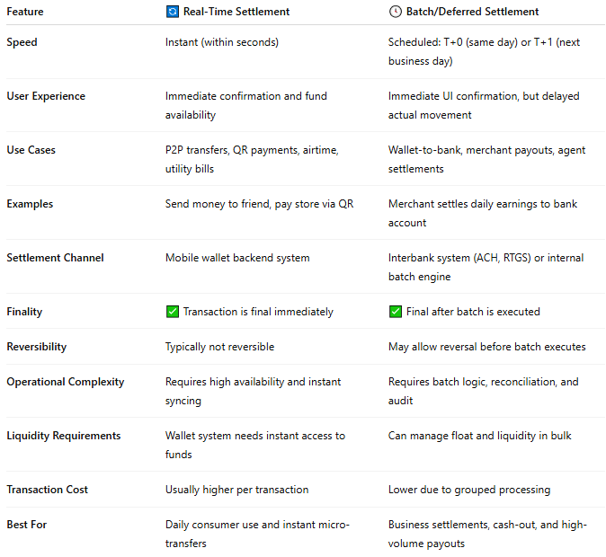

Feature | 🔄 Real-Time Settlement | 🕓 Batch/Deferred Settlement
Speed | Instant (within seconds) | Scheduled: T+0 (same day) or T+1 (next business day)
User Experience | Immediate confirmation and fund availability | Immediate UI confirmation, but delayed actual movement
Use Cases | P2P transfers, QR payments, airtime, utility bills | Wallet-to-bank, merchant payouts, agent settlements
Examples | Send money to friend, pay store via QR | Merchant settles daily earnings to bank account
Settlement Channel | Mobile wallet backend system | Interbank system (ACH, RTGS) or internal batch engine
Finality | ✅ Transaction is final immediately | ✅ Final after batch is executed
Reversibility | Typically not reversible | May allow reversal before batch executes
Operational Complexity | Requires high availability and instant syncing | Requires batch logic, reconciliation, and audit
Liquidity Requirements | Wallet system needs instant access to funds | Can manage float and liquidity in bulk
Transaction Cost | Usually higher per transaction | Lower due to grouped processing
Best For | Daily consumer use and instant micro-transfers | Business settlements, cash-out, and high-volume payouts

🧠 When to Use Each
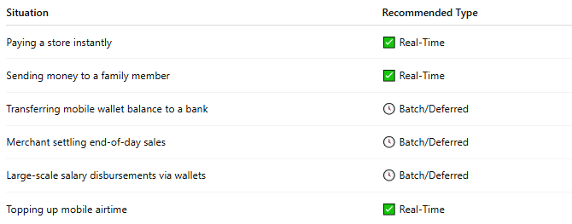

Situation | Recommended Type
Paying a store instantly | ✅ Real-Time
Sending money to a family member | ✅ Real-Time
Transferring mobile wallet balance to a bank | 🕓 Batch/Deferred
Merchant settling end-of-day sales | 🕓 Batch/Deferred
Large-scale salary disbursements via wallets | 🕓 Batch/Deferred
Topping up mobile airtime | ✅ Real-Time

🧠 Summary
# Source: AI Source: Provided by: [Data Path: Persons Table -> ID Column: 1, Name_En Column: Motasem Essam] -> From: [ChatGPT] on [1/21/2026]
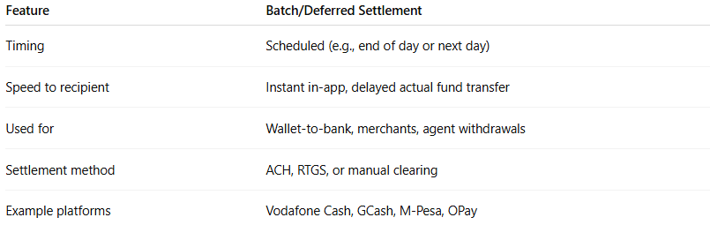

Feature | Batch/Deferred Settlement
Timing | Scheduled (e.g., end of day or next day)
Speed to recipient | Instant in-app, delayed actual fund transfer
Used for | Wallet-to-bank, merchants, agent withdrawals
Settlement method | ACH, RTGS, or manual clearing
Example platforms | Vodafone Cash, GCash, M-Pesa, OPay

